
Tripoli Motor Testing Division
223 NC Highway 54 West
Chapel Hill, NC 27514
(919) 357 5681 (c)
October 31, 2022

Gary Rosenfield
RCS Rocket Motor Components, Inc.
2113 West 850 North Street
Cedar City, UT 84721

Dear Mr. Rosenfield,

The Classic Enerjet by Aerotech F67C single-use motor was tested on October 26, 2022 and complies with NFPA 1125. The motor is certified for hobby rocketry use by the members of the Tripoli Rocketry Association and all approving organizations with reciprocal certifying agreements.

Motor Manufacturer RCS Rocket Motor Components, Inc.
Manufacturer’s Designation {F67-6,9,14C} [single use]
Propellant Classic
TMT Nomenclature 77 F55

Diameter 1.131” 28.74 mm
Overall Length 4.42” 112.35 mm
Outside the MMT 0.94” 23.97 mm

Loaded Mass 0.189 lb 85.67 g
Propellant Mass 0.0811 lb* 36.8 g*
Burnout Mass 0.096 lb 43.38 g
* = data provided by manufacturer

Burn time 1.411 ± 0.057 sec

Total Impulse 17.34 ± 0.254 lbf.s 77.46 ± 1.867 N.s
Max Impulse 16.363 ± 1.092 lbf 72.79 ± 4.859 N
Average Impulse 12.413 ± 0.342 lbf 55.22 ± 1.519 N
Number of Motors Tested 10

Nominal Measured
Delay Time Data 6 s 7.072, 6.62, 6.052, 5.938 s
9 s 9.078, 8.723, 9.115 s
14 s 12.883, 12.526, 12.766 s

Casing Temp. [NFPA 1125 7.4.1] Passed

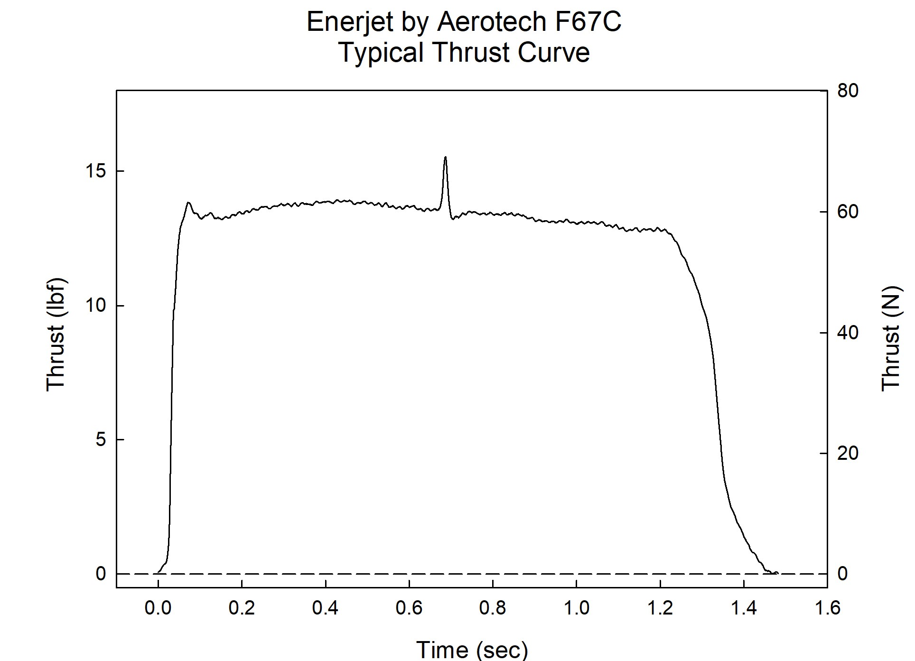

Sincerely,

Alan C. Whitmore
Chair, Tripoli Motor Testing

